#229
Customer(s): |  |  | USP Grade Customers 6X7=42 |  |  |  |  |  |  |  |  |  |  |  |  |  | 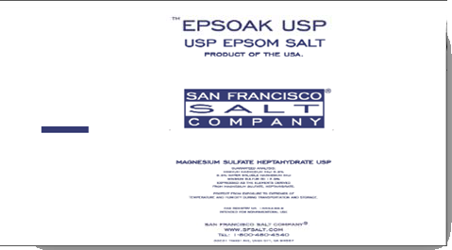
Product: |  | U50-SFBS
 | - Tech Grade |  |  |  |  |  |  |  |  |  | - USP Grade |  |  |  |  | - Liquid
 | - Screened 20/60 |  |  |  |  |  |  |  |  |  | - Screened 60 |  |  |  |  | - Other |  |  | OVERS
 | - Take Samples
Production/Packaging:
 | Type of Film |  |  |  | Customer Supplied Film |  |  |  |  |  |  |  |  |  | Weight per Bag |  |  |  |  | 50 lbs
 | Number of Bags per pallet |  |  |  |  |  |  |  |  | 42 |  |  |  |  | Pallet Configuration |  |  |  |  |  | 7 per layer x 6 layers
 | Type of Sacks |  |  |  |  |  |  |  |  |  |  |  |  | Weight per Bag
 | - Shrink Wrap |  |  |  |  |  |  |  |  |  | - Date, Time & Lot # on each Bag |  |  |  |  |  |  | - Number and Initial each pallet
 | - Liners Required |  |  |  |  |  |  |  |  |  | - Heat Treated Pallets |  |  |  |  |  |  | - Super Sack Tags
 | - Placards or Tags Required |  |  |  |  |  |  |  |  |  |  | “6X7=42”
 | - Stickers Required
 | - Other Requirements

Shipping:
 | - General |  |  |  |  | Load according to Giles loading chart and quantity on Bill of Lading
 | - Air Bags |  |  |  |  |  |  |  |  |  | - Double Wrap |  |  |  |  | - Corner Boards |  |  |  |  |  | - Block & Brace
 | - Must have Quality Approval before loading |  |  |  |  |  |  |  |  |  |  |  |  |  | - Must have Management Approval before loading
 | - Other |  |  | Load 40’ RXR containers according to chart in shipping instructions
Change Information: |  |  |  |  |  | 8/14/15 Changed to OVERS material, updated to new format.

